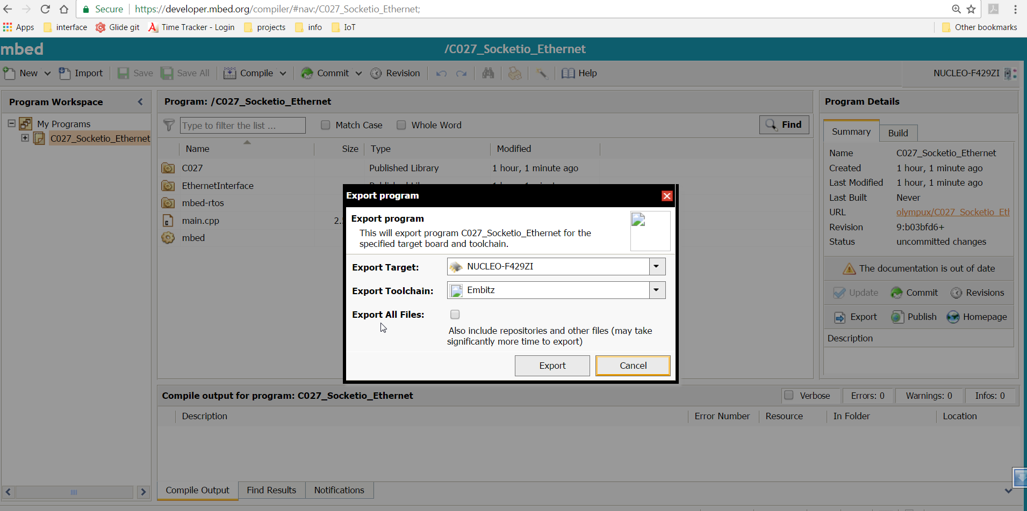
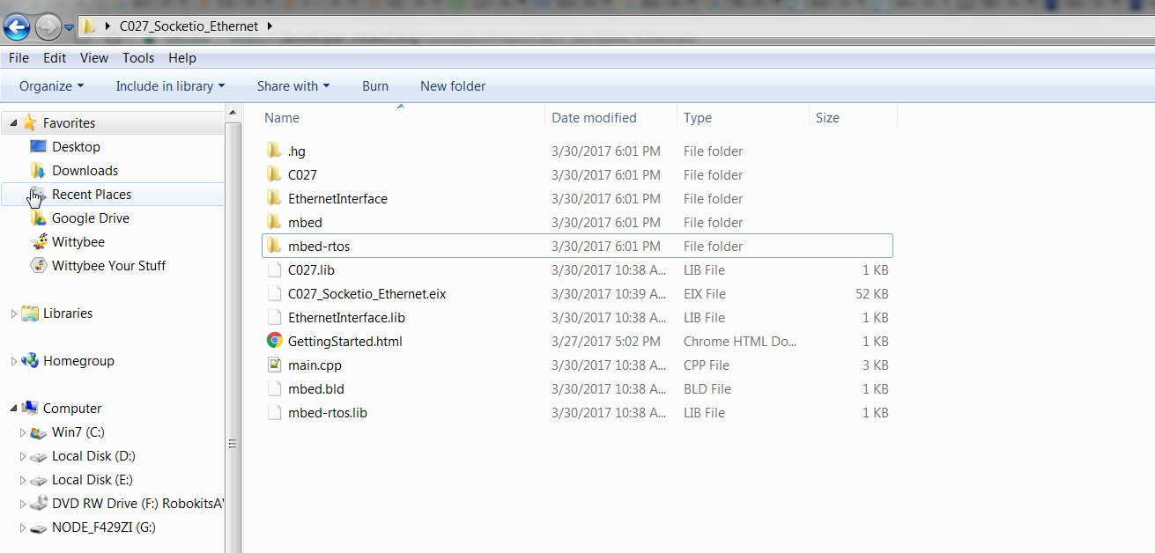

Here I have selected option of EmBitz as a Toolchain ,but no project file has been created that you can see from both of this image. Please help me as soon as possible.

